Meeting 25
Course / Class #: CECS 4800

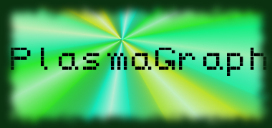
Date: 3 April 2014
Project Name: PlasmaGraph

Has been done:
- Bug-Fixing.
- Basic grouping. (Can group by numerical columns. Not tested with string-typed columns. Doesn't work yet with Interpolations due to bugs.)
- Research on Help File viewing via Java.

What will be done:
1) Bug fixing. (Error catching for any and all edge cases with graphing (Sometimes, incorrect graphs appear or unhandled nulls might be thrown.) or option-selection. )
2) Interpolation grouping, and grouping by string-typed columns.
3) Help File viewing. (Possibly as a replacement to the User Manual required by the project.)
4) Update Specification documentation to match current work (SDD, STD)

Materials Used: 2x Computers, Internet connections, Microsoft Visio / Dia (Diagramming Tools), Eclipse / NetBeans IDE (Programming Tools).

Group Members: ________________________________
Gerardo A. Navas

________________________________
Daniel Quintini

Professor:

________________________________
Prof. Luis A. Ortiz

